EXPT 3 Benchmarking of 5G/6G Communication for IoE Applications based on Throughput, Latency, Reliability and Energy Efficiency

Objective:
- To simulate and benchmark 5G communication performance for IoE applications using Python in Google Colab.
- To calculate throughput for different numbers of IoE devices.
- To analyze latency and reliability under varying network loads.
- To evaluate energy efficiency in terms of Mbit/J.
- To plot and compare the four performance metrics as the number of IoE devices increases.
Procedure
- Open Google Colab and create a new Python notebook.
- Import the Matplotlib library for plotting graphs.
- Define the number of IoE devices, network capacity, base latency, packet success rate, and energy consumption parameters.
- Calculate the total packets generated and the offered traffic load for each device count.
- Calculate throughput based on offered load, packet success rate, and network capacity.
- Calculate latency based on network utilization and congestion.
- Calculate reliability as a percentage using the packet success rate and network utilization.
- Calculate energy efficiency based on successfully transmitted data and total energy consumed.
- Display the calculated throughput, latency, reliability, and energy efficiency for each device count.
10.Plot all four performance metrics using Matplotlib and analyze the graphs.

Program:
import matplotlib.pyplot as plt
# Number of IoE devices
devices = [15, 60, 110, 225, 350, 420, 550,650]
# 5G network parameters (assumed)
capacity = 100 # Mbps
base_latency = 10 # ms
packet_success_rate = 0.98
energy_per_packet = 0.001 # Joules
# IoE device parameters
packet_size = 1200 # Bytes
packets_per_second = 20
simulation_time = 10 # Seconds
# Store results
throughput = []
latency = []
reliability = []
energy_efficiency = []
for n in devices:
total_packets = n * packets_per_second * simulation_time
offered_load = (
n * packets_per_second * packet_size * 8 / 1e6
)
# Network utilization
utilization = offered_load / capacity
# 1. Throughput (Mbps)
t = min(
offered_load * packet_success_rate,
capacity
)
# 2. Latency (ms): increases with congestion
u = min(utilization, 0.95)
l = base_latency + 10 * u / (1 - u)
# 3. Reliability (%): decreases with congestion
r = 100 * packet_success_rate * max(
0, 1 - 0.2 * utilization
)
# 4. Energy efficiency (Mbit/J)
successful_packets = total_packets * r / 100
total_energy = (
total_packets
* energy_per_packet
* (1 + utilization)
)
e = (
successful_packets * packet_size * 8
/ total_energy / 1e6
)
# Store values
throughput.append(t)
latency.append(l)
reliability.append(r)
energy_efficiency.append(e)
# Display results
print(f"\nIoE Devices: {n}")
print(f"Offered Load : {offered_load:.2f} Mbps")
print(f"Throughput : {t:.2f} Mbps")
print(f"Latency : {l:.2f} ms")
print(f"Reliability : {r:.2f} %")
print(f"Energy Efficiency : {e:.2f} Mbit/J")
# Plot all four performance metrics
metrics = [
(throughput, "Throughput (Mbps)"),
(latency, "Latency (ms)"),
(reliability, "Reliability (%)"),
(energy_efficiency, "Energy Efficiency (Mbit/J)")
]
fig, axes = plt.subplots(2, 2, figsize=(11, 8))
for ax, (values, title) in zip(axes.flat, metrics):
ax.plot(devices, values, marker="o")
ax.set_title(title)
ax.set_xlabel("Number of IoE Devices")
ax.set_ylabel(title)
ax.grid(True)

plt.suptitle("5G Performance Benchmarking for IoE Applications")
plt.tight_layout()
plt.show()
Output:
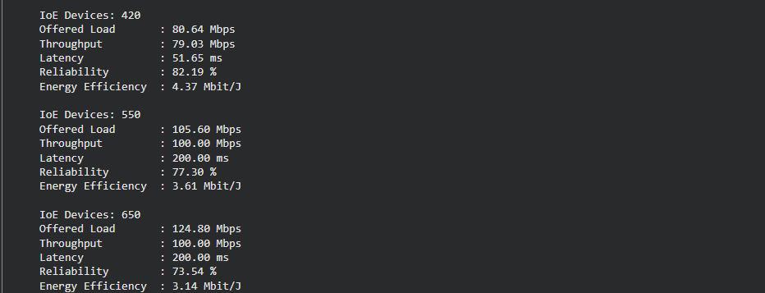
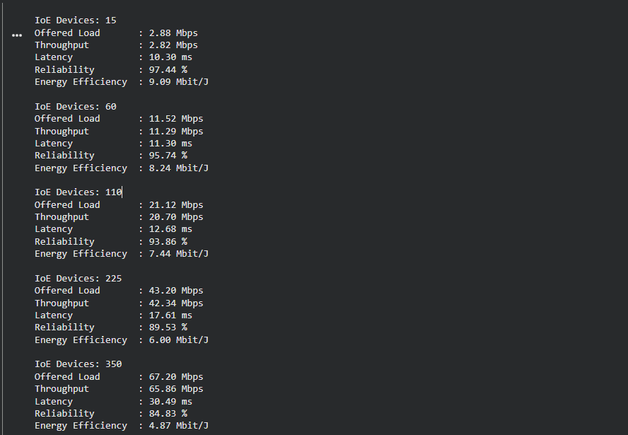

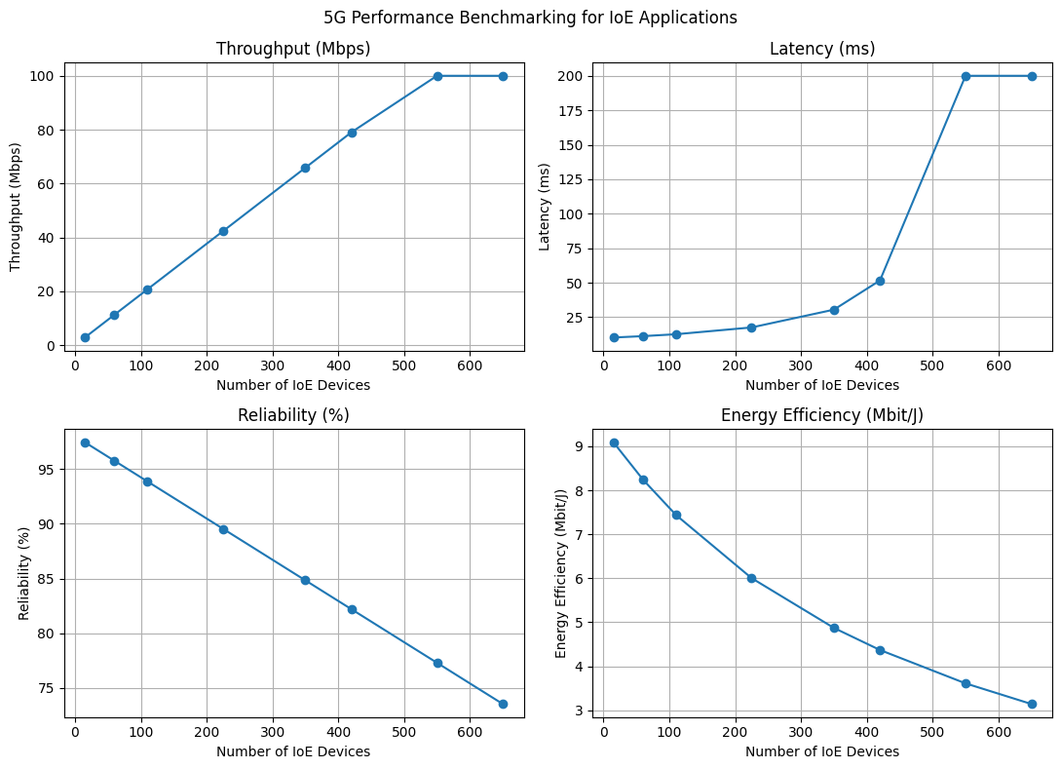

Table:

 |  | Number of IoT Devices
 |  | 15 | 60 | 110 | 225 | 350 | 420 | 550 (Max) | 650(Max)
5G | Offered Load | 2.88 Mbps | 11.52 Mbps | 21.12 Mbps | 43.20 Mbps | 67.20 Mbps | 80.64 Mbps | 105.06 Mbps | 124.80 Mbps
5G | Throughput | 2.82 Mbps | 11.29 Mbps | 20.70 Mbps | 42.34 Mbps | 65.86 Mbps | 79.03 Mbps | 100.00 Mbps | 100.00 Mbps
5G | Latency | 10.30 ms | 11.30 ms | 12.68 ms | 17.61 ms | 30.49 ms | 51.65 ms | 200.00 ms | 200.00 ms
5G | Reliability | 97.44% | 95.74% | 93.86% | 89.53% | 84.83% | 82.19% | 77.30% | 73.54%
5G | Energy Efficiency | 9.09 Mbit/J | 8.24 Mbit/J | 7.44 Mbit/J | 6.00 Mbit/J | 4.87 Mbit/J | 4.37 Mbit/J | 3.61 Mbit/J | 3.14 Mbit/J

Result
The 5G communication performance benchmarking for IoE applications was successfully simulated using Python in Google Colab. Throughput, latency, reliability, and energy efficiency were calculated for different numbers of IoE devices and represented graphically. The simulation demonstrates how increasing device count and network load can affect communication performance under the assumed model parameters.

